1. Create virtual machine with guest additions.

* Inserted the virtual disk and ran the Virtual Box guest additions executable to have machine run properly.
* Created shared file on desktop named “Malware”
* Enabled drag-and-drop and copy and paste shared by both host and guest OS.
* Virtual box installation and provided 4 CPU’s and 8GB of ram.
* Kali machine provided 4 gb’s and 8gb of ram.

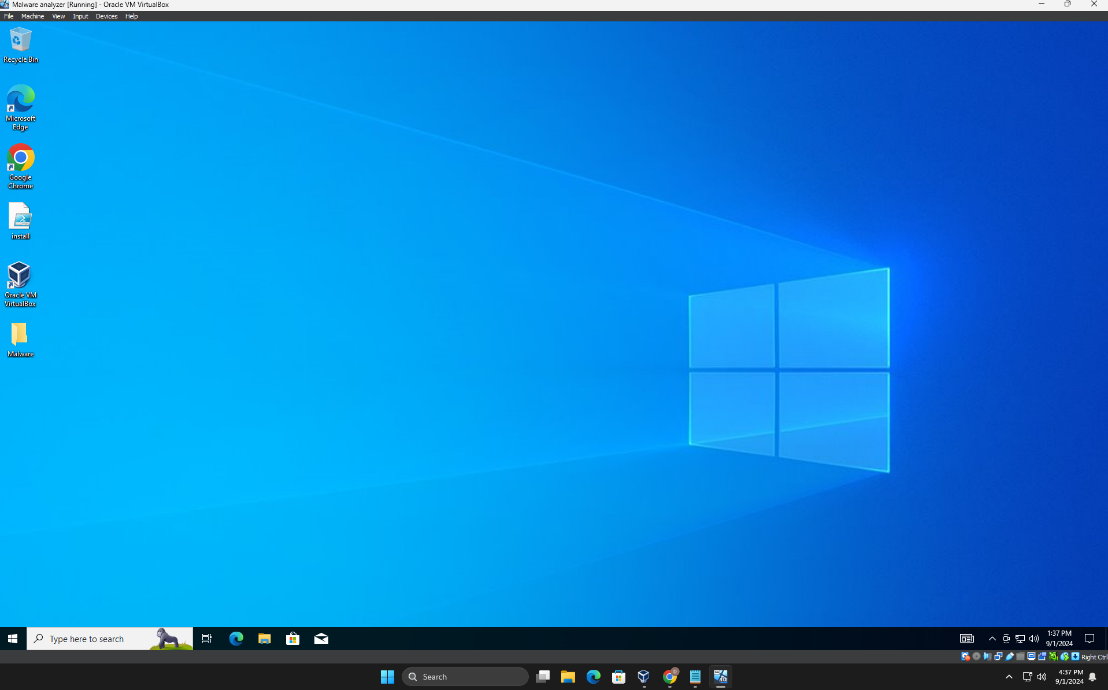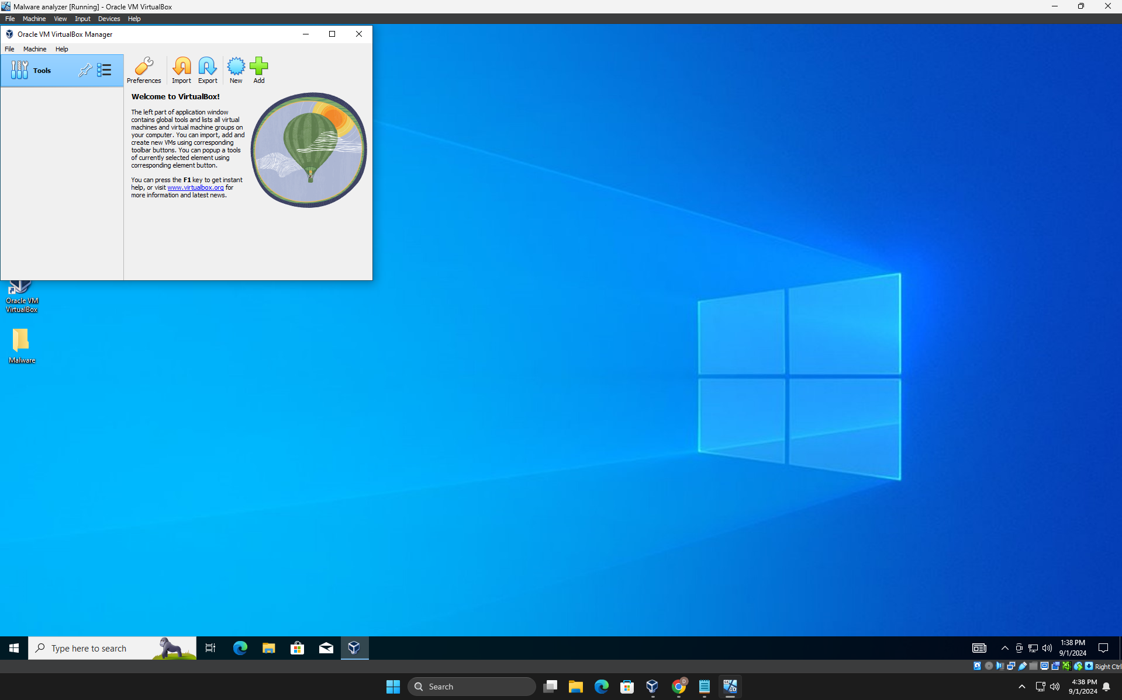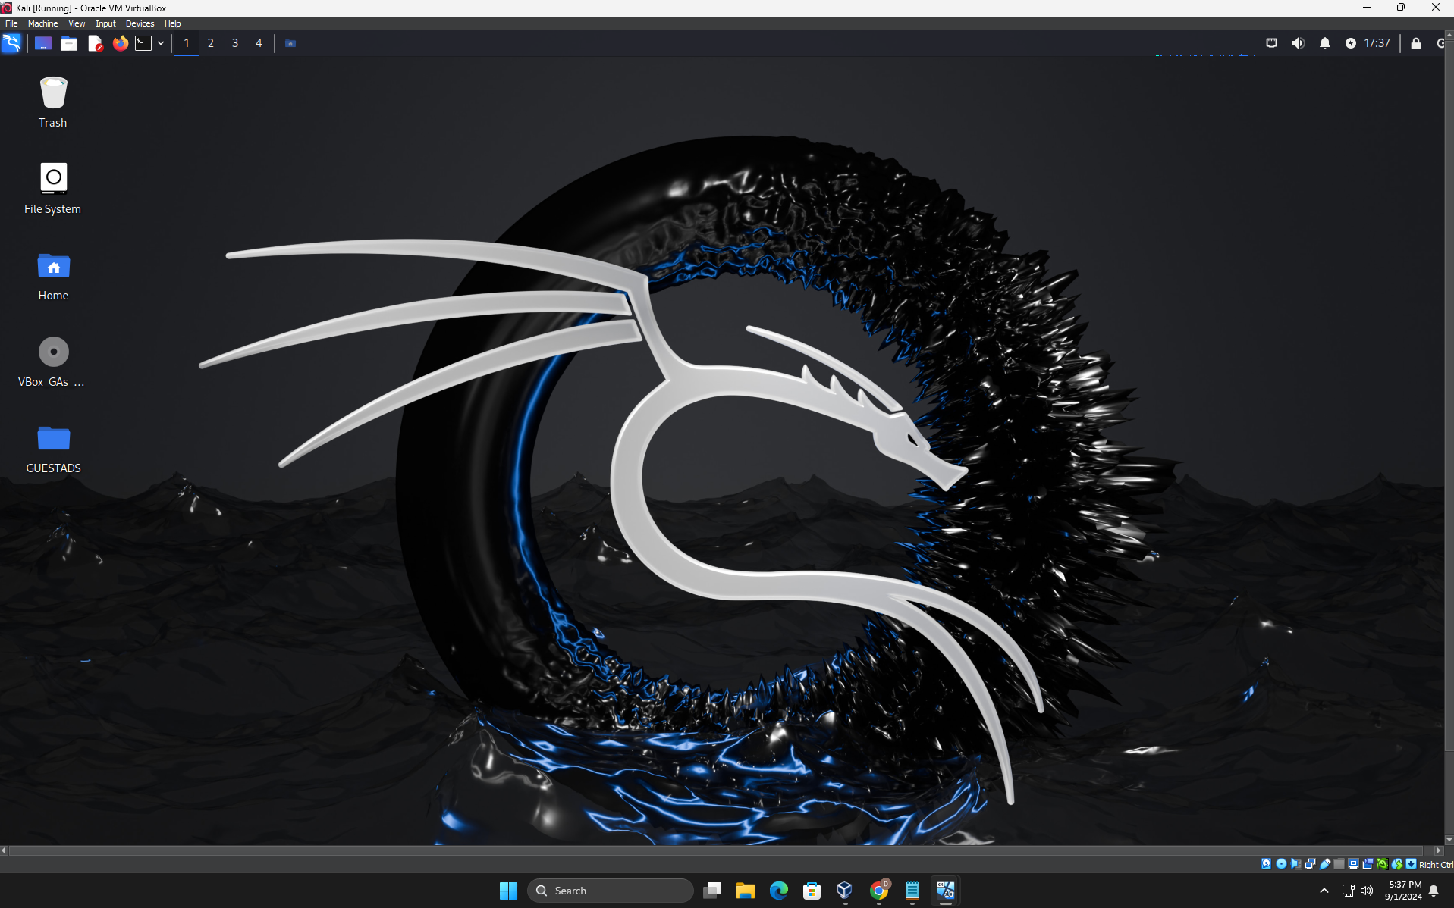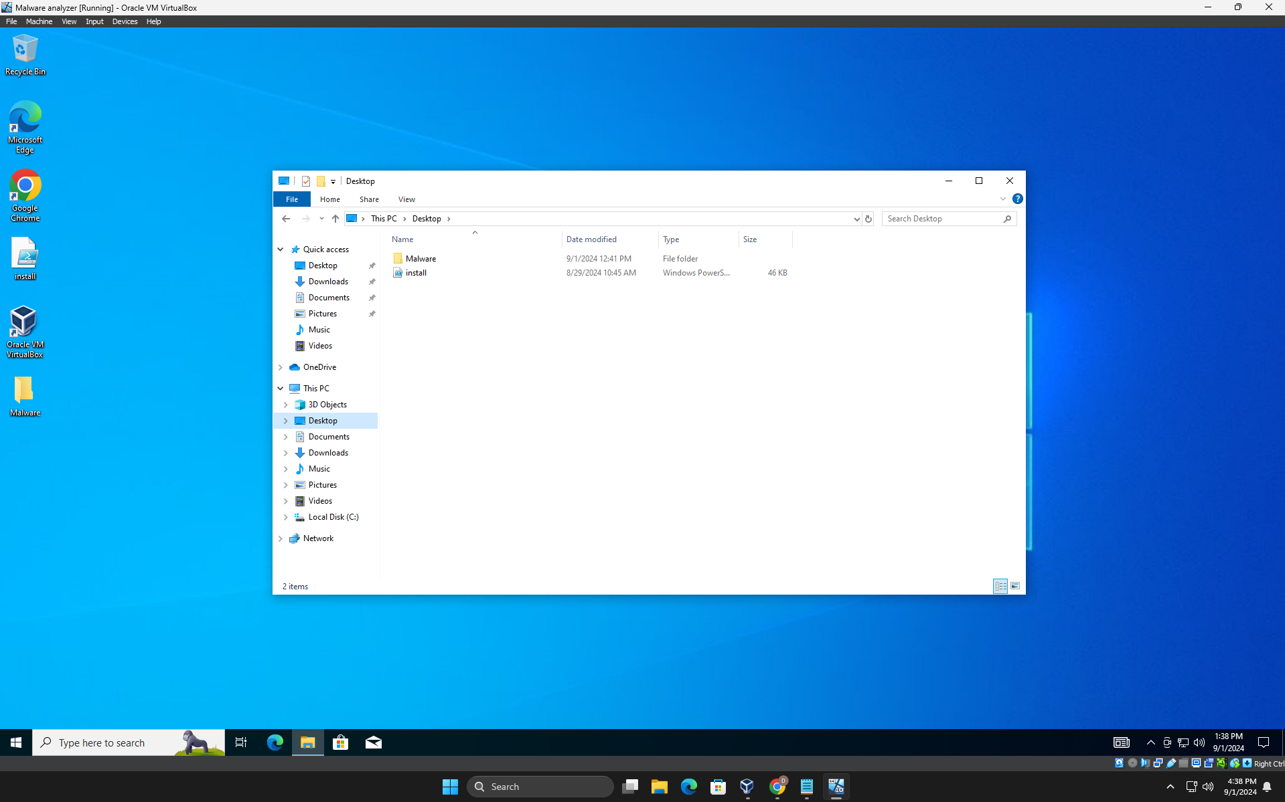

1. Basic Kali comands

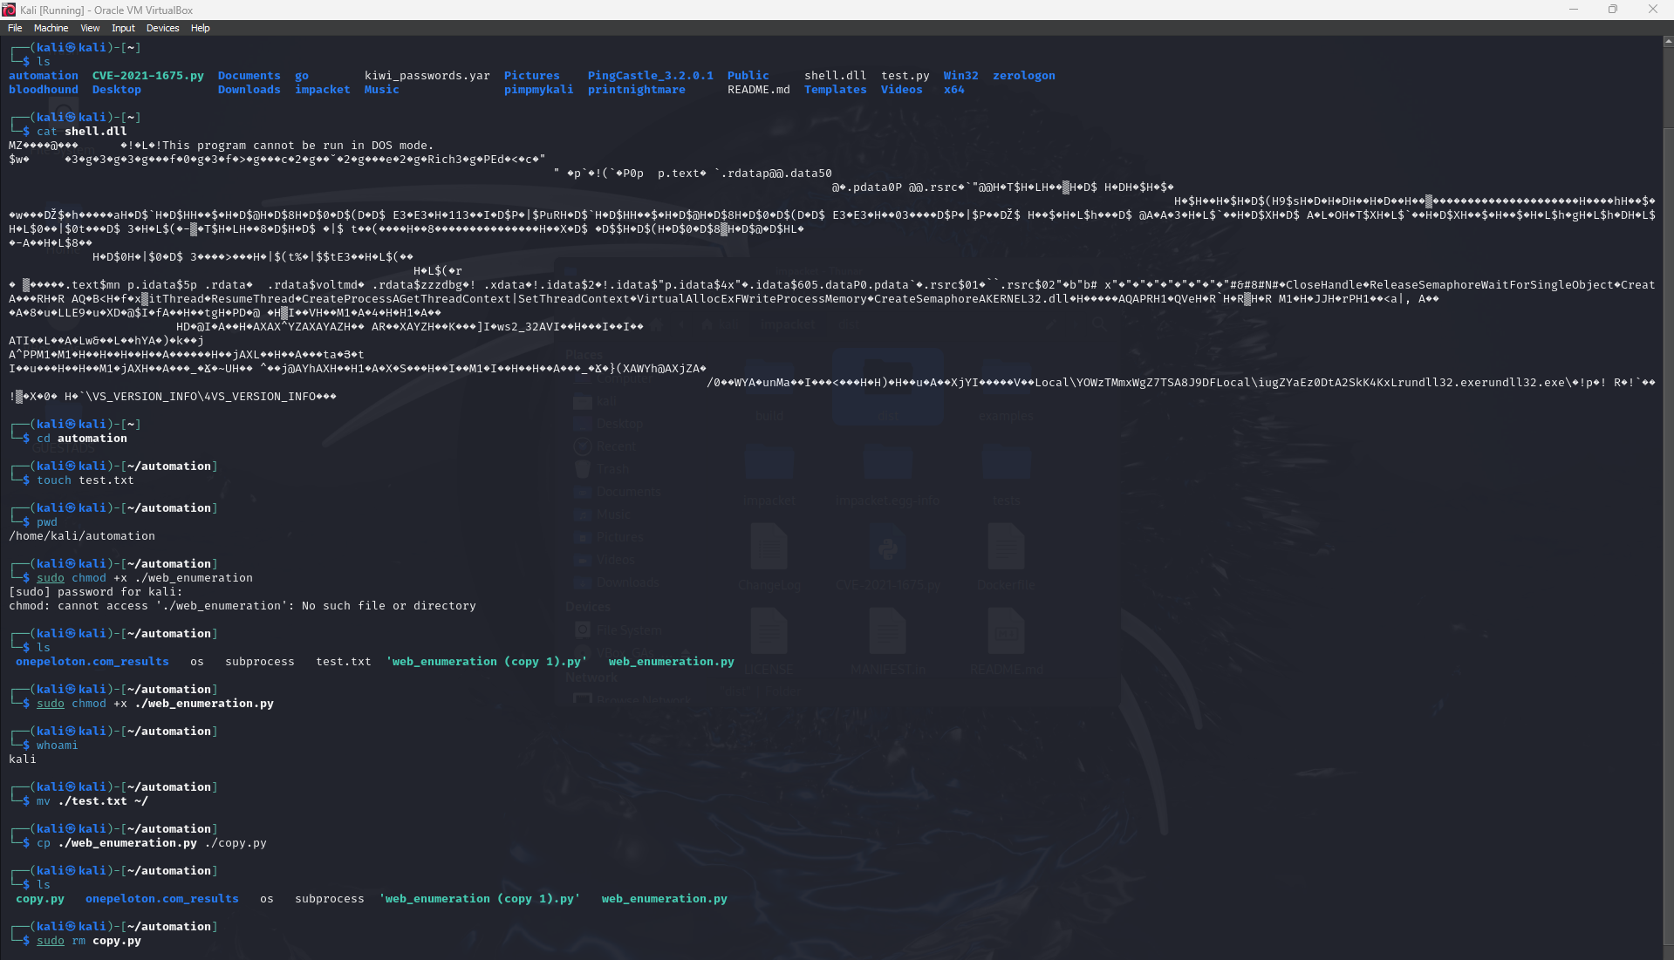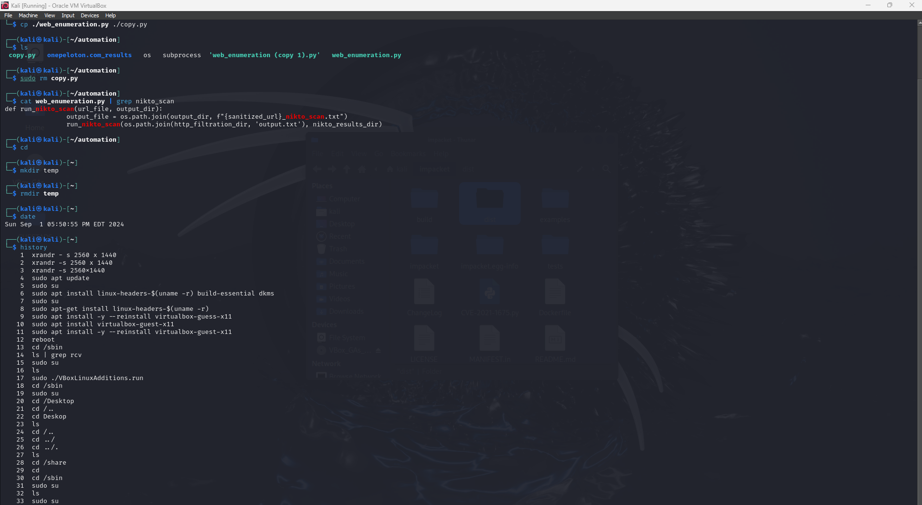

1. Compiling and running C++ code

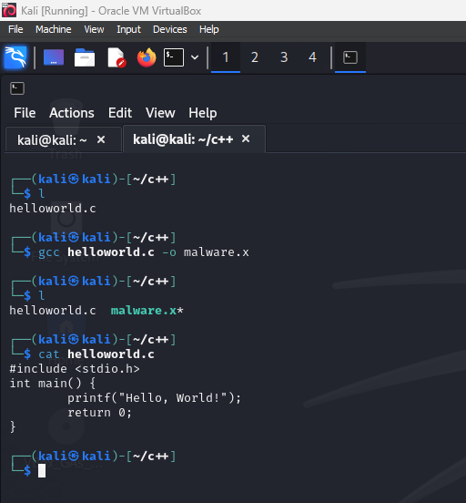

1. Flare VM Installation

With the Flare VM installation, the prerequisites required before installation is to turn off Windows Defender, real time scanning, and any more of anti-virus that would prevent the script from running correctly. Along with this, updates were turned off to ensure nothing can interfere with the Flare VM process. In the beginning after the installation is fresh, a snapshot of the virtual machine is taken, in order to make sure you retain a safe instance, and one after the script is finished to ensure you have a safe point.

